**Chapter 1**

**Parametric Equations and Polar Coordinates**

**1.3 Polar Coordinates**

**Section Exercises**

**In the following exercises, plot the point whose polar coordinates are given by first constructing the angle  and then marking off the distance *r* along the ray.**

1. 

Answer:

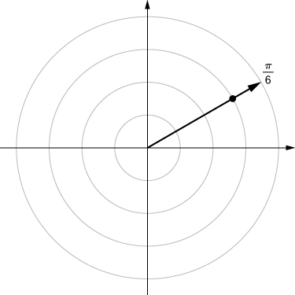

1. 

Answer:

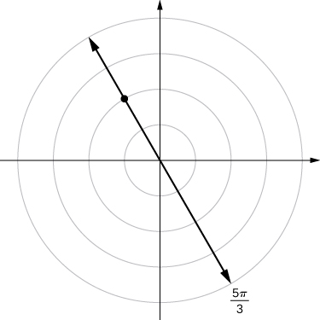

1. 

Answer:

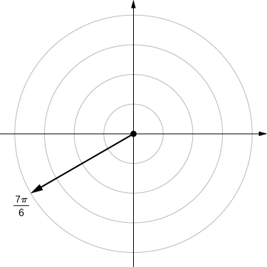

1. 

Answer:

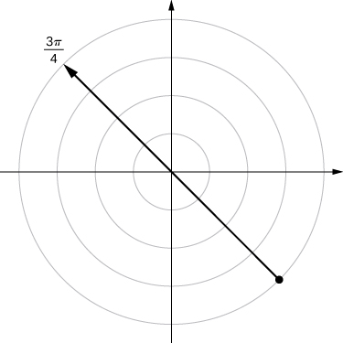

1. 

Answer:

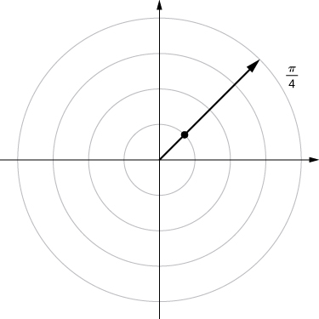

1. 

Answer:

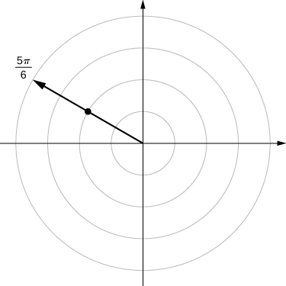

1. 

Answer:

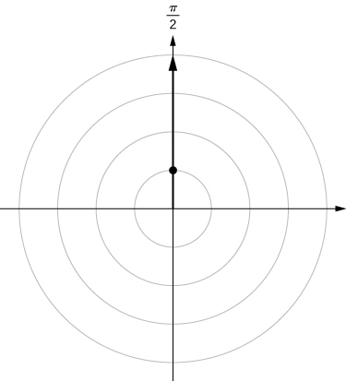

**For the following exercises, consider the polar graph below. Give two sets of polar coordinates for each point.**

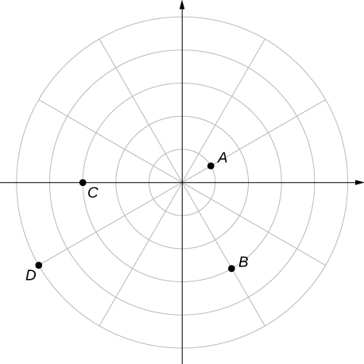

1. Coordinates of point *A*.

Answer: 

1. Coordinates of point *B*.

Answer: 

1. Coordinates of point *C*.

Answer: 

1. Coordinates of point *D*.

Answer: 

**For the following exercises, the rectangular coordinates of a point are given. Find two sets of polar coordinates for the point in  Round to three decimal places.**

1. 

Answer: 

1.  (3,–4)

Answer: 

1. 

Answer: 

1. 

Answer: 

1. 

Answer: 

1. 

Answer: 

**For the following exercises, find rectangular coordinates for the given point in polar coordinates.**

1. 

Answer: 

1. 

Answer: 

1. 

Answer: 

1. 

Answer: 

1. 

Answer: 

1. 

Answer: 

1. 

Answer: 

**For the following exercises, determine whether the graphs of the polar equation are symmetric with respect to the-axis, the-axis, or the origin.**

1. 

Answer: Symmetry with respect to the *x*-axis, *y*-axis, and origin.

1. 

Answer: Symmetry with respect to the *x*-axis, *y*-axis, and origin.

1. 

Answer: Symmetric with respect to *x*-axis only.

1. 

Answer: Symmetry with respect to *x*-axis only.

1. 

Answer: Symmetry with respect to *x*-axis only.

**For the following exercises, describe the graph of each polar equation. Confirm each description by converting into a rectangular equation.**

1. 

Answer: Circle of radius 3.

1. 

Answer: Line 

1. 

Answer: 

1. 

Answer: 

**For the following exercises, convert the rectangular equation to polar form and sketch its graph.**

1. 

Answer: Circle of radius 4; polar form 

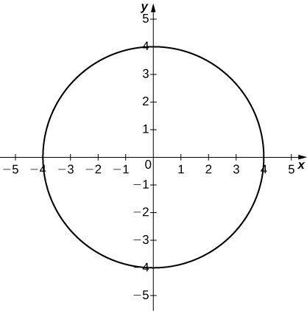

1. 

Answer: Hyperbola; polar form  or 

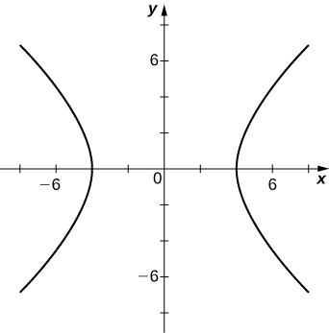

1. 

Answer: Vertical line; polar form:  or 

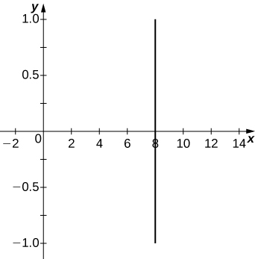

**For the following exercises, convert the rectangular equation to polar form and sketch its graph.**

1. 

Answer: 

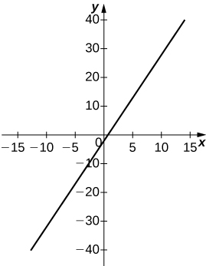

1. 

Answer: 

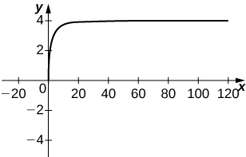

**For the following exercises, convert the polar equation to rectangular form and sketch its graph.**

1. 

Answer: 

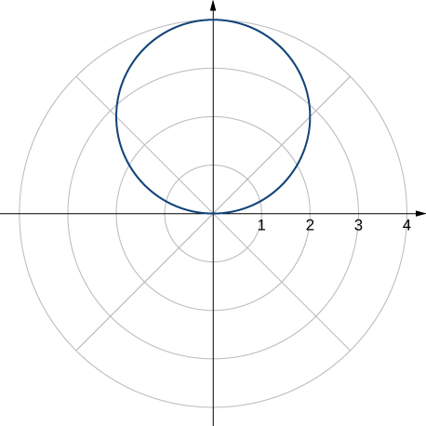

1. 

Answer: 

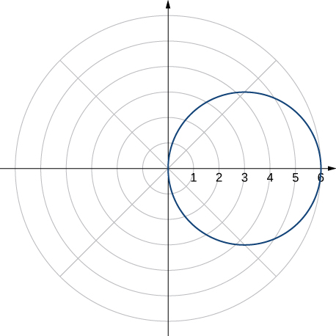

1. 

Answer: 

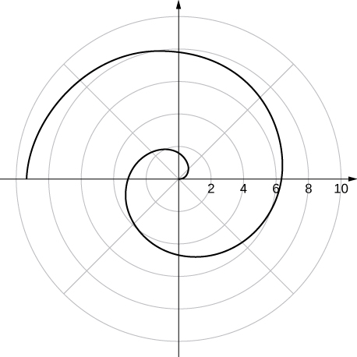

1. 

Answer:. 

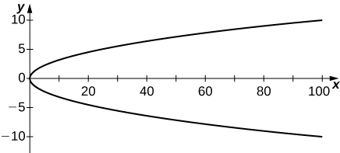

**For the following exercises, sketch a graph of the polar equation and identify any symmetry.**

1. 

Answer:

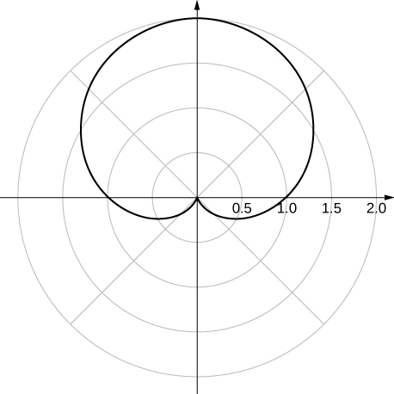

*y*-axis symmetry

1. 

Answer:

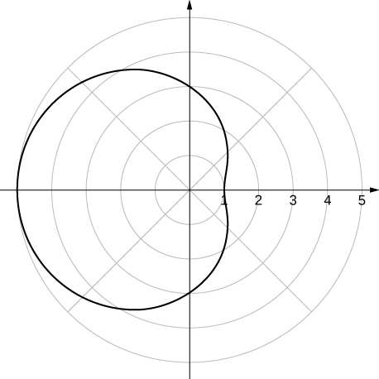

*x*-axis symmetry

1. 

Answer:

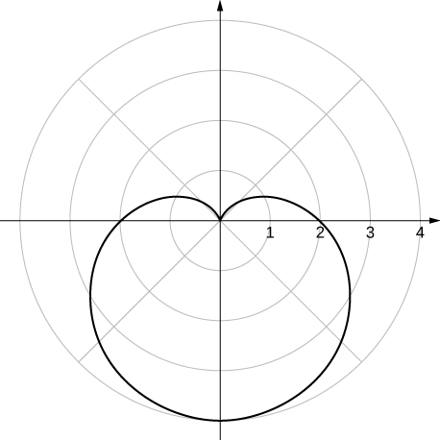

*y*-axis symmetry

1. 

Answer:

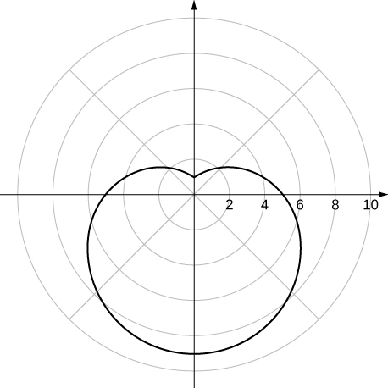

*y*-axis symmetry

1. 

Answer:

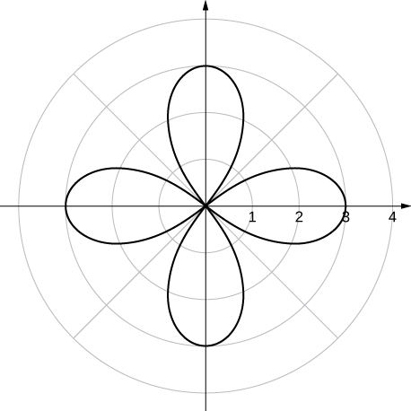

*x*- and *y*-axis symmetry and symmetry about the pole

1. 

Answer:

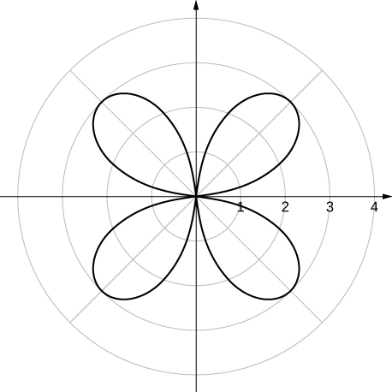

*x*- and *y*-axis symmetry and symmetry about the pole

1. 

Answer:

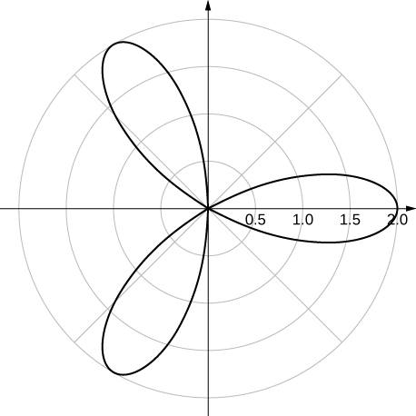

*x*-axis symmetry

1. 

Answer:

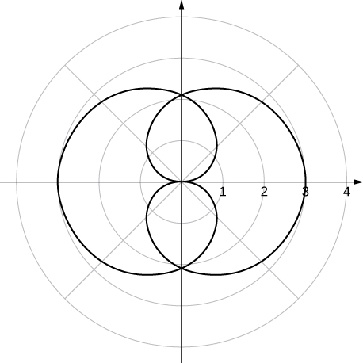

*x*- and *y*-axis symmetry

1. 

Answer:

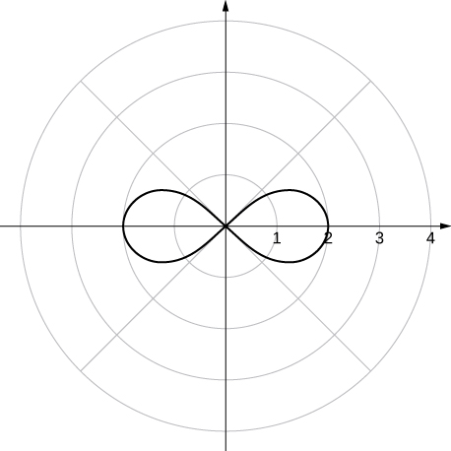

*x*- and *y*-axis symmetry and symmetry about the pole

1. 

Answer:

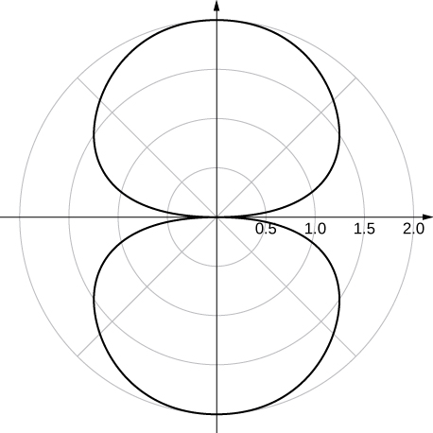

*x*- and *y*-axis symmetry

1. 

Answer:

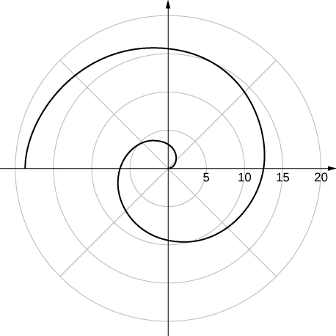

no symmetry

1. **[T]** The graph of ..is called a *strophoid.* Use a graphing utility to sketch the graph, and, from the graph, determine the asymptote.

Answer:

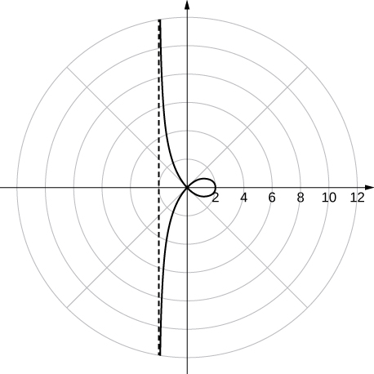

From the graph, it appears that the vertical line  is an asymptote.

1. **[T]** Use a graphing utility and sketch the graph of 

Answer:

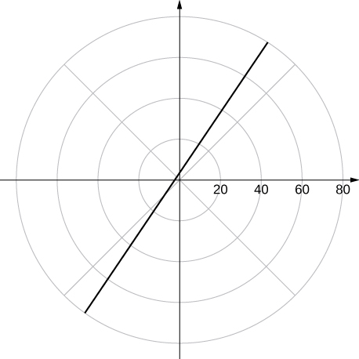

a line

1. **[T]** Use a graphing utility to graph 

Answer:

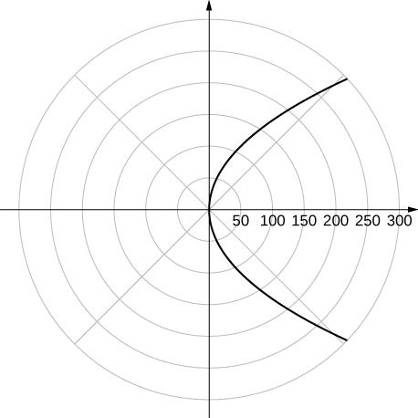

The graph is a parabola.

1. **[T]** Use technology to graph 

Answer:

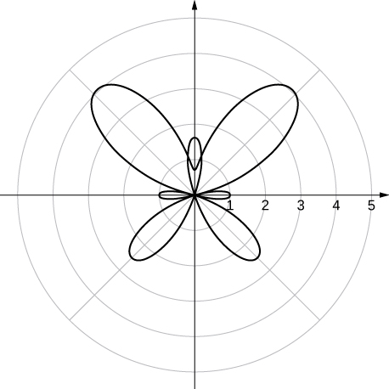

1. **[T]** Use technology to plot  (use the interval 

Answer:

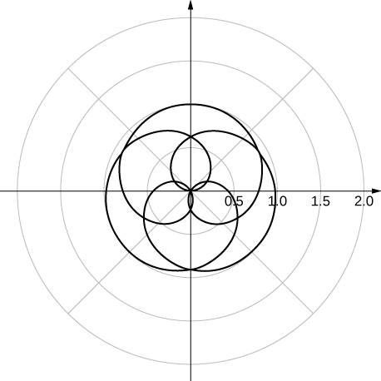

1. Without using technology, sketch the polar curve 

Answer:

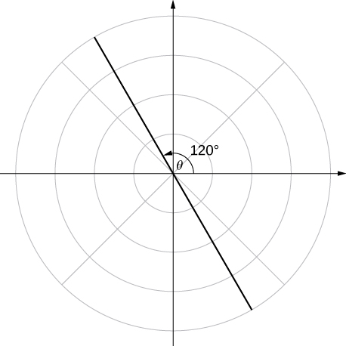

1. **[T]** Use a graphing utility to plot  for

Answer:

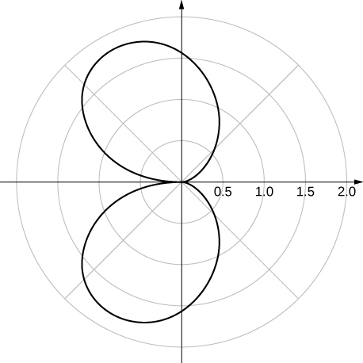

1. **[T]** Use technology to plot  for 

Answer:

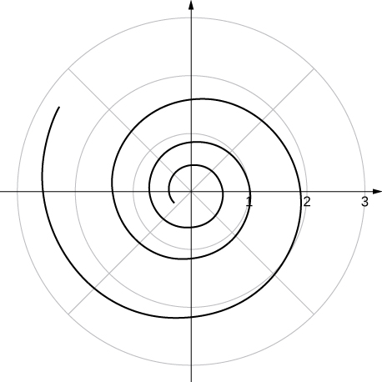

1. **[T]** There is a curve known as the “*Black Hole*.” Use technology to plot for 

Answer:

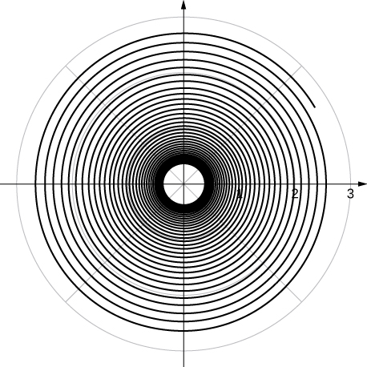

1. **[T]** Use the results of the preceding two problems to explore the graphs of and  for 

Answer: Answers vary. One possibility is the spiral lines become closer together and the total number of spirals increases.

This file is copyright 2016, Rice University. All Rights Reserved.